Experiment No: 1 Date : 13/02/2025
Familiarization of DDL Commands

Data Definition Language (DDL) - These SQL commands are used for creating, modifying, and dropping the structure of database objects. The commands are CREATE, ALTER, DROP, RENAME, and TRUNCATE.

- Consider the database for a college. Write SQL commands to implement the following:

  - Create a database
>> create database college;

  - Select the current database
>> use college;

  - Create the following tables:

    - Student (roll_no integer, name varchar, dob date, address text, phone_no varchar, blood_grp varchar)

>> create table student(roll_no int,name varchar(10),dob date,address varchar(10),phone_no varchar(10),blood_grp varchar(10));

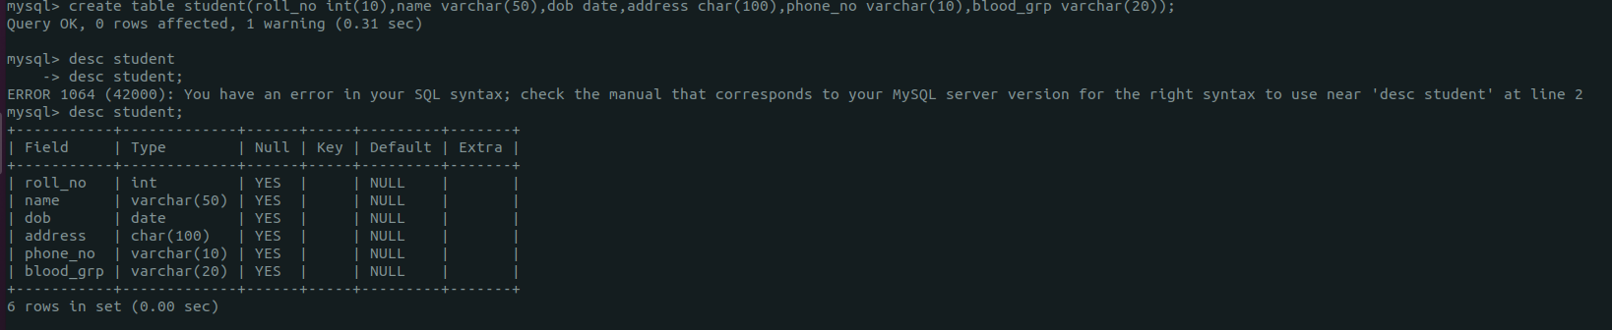
    - Course (Course_id integer, Course_name varchar, course_duration integer)

>> create table course(course_id int,course_name varchar(10),course_duration int);

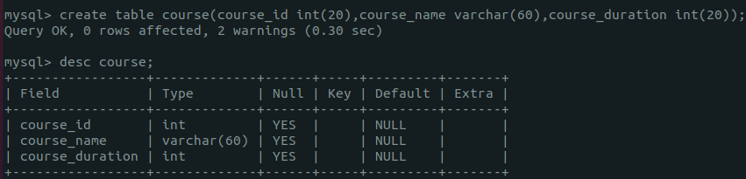

  - List all tables in the current database.

>> show tables;
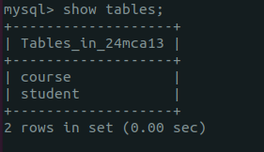

  - Display the structure of the Student table.

>> describe student;

  - Drop the column blood_grp from Student table.

>> alter table student drop column blood_grp;

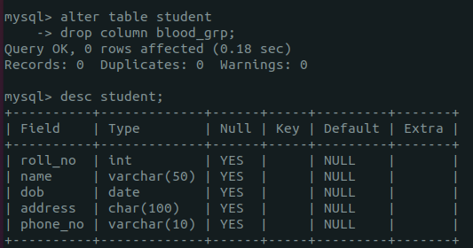

  - Add a new column Adar_no with domain number to the table Student.

>> alter table student add column adar_no int;

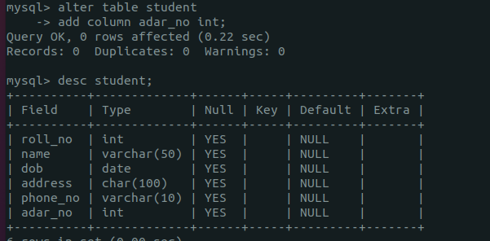
  - Change the datatype of phone_no from varchar to int

>> alter table student modify phone_no int;

  - Drop the tables.

>> drop table student;
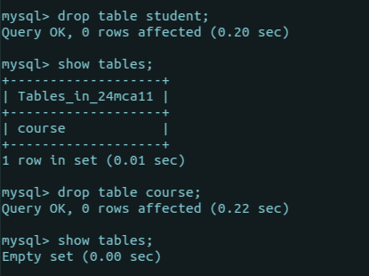
- Consider the database for an organization. Write SQL commands to implement the following:

  - Create a database
>> create database company;

  - Select the current database
>> use company;

  - Create the following tables:

    - Employee (emp_no varchar, emp_name varchar, dob date, address text, mobile_no integer, dept_no varchar, salary integer)

>> create table employee(emp_no varchar(10),emp_name varchar(10),dob date,address varchar(10),mobile_no int,dept_no varchar(10),salary int);
\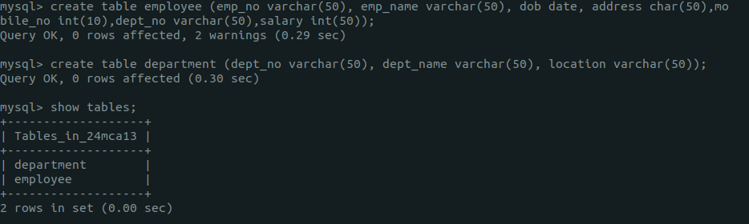

    - Department (dept_no varchar, dept_name varchar, location varchar)

>> create table department(dept_no varchar(10),dept_name varchar(10),location varchar(10));

  - List all tables in the current database.

>> show tables;

  - Display the structure of the Employee table and Department table.

>> describe department;

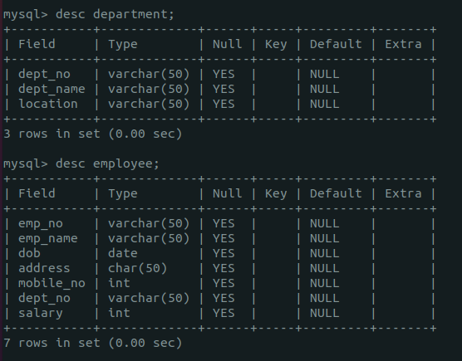

>> describe employee;

  - Add a new column ‘Designation’ to the table Employee.

>> alter table employee add column designation varchar(10);

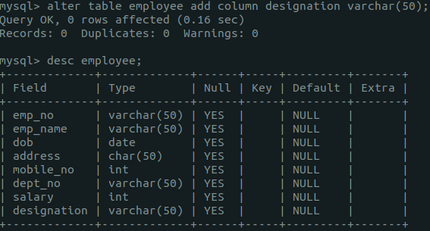

  - Drop the column ‘location’ from Department table.

>> alter table department frop column location;

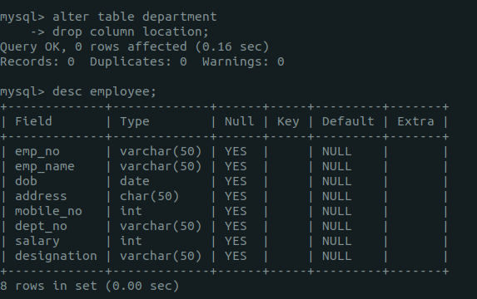
Experiment No: 2 Date : 13/02/2025
Familiarization of SQL Constraints.

- Create new table Persons with attributes PersonID (integer, PRIMARY KEY), Name (varchar , NOT NULL), Aadhar (Number, NOT NULL, UNIQUE), Age (integer , CHECK>18).

>> create table persons(person_id int primary key,name varchar(10) not null,aadhar int not null unique,age int,check(age>=18));

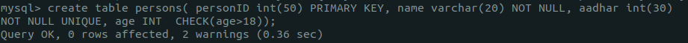

- CREATE TABLE Orders with attributes OrderID (PRIMARY KEY), OrderNumber(NOT NULL) and PersonID( set FOREIGN KEY on attribute PersonID referencing the column PersonId of Person table)

>> create table orders(order_id int primary key,order_no int not null,person_id int,foreign key(person_id)references persons(person_id));

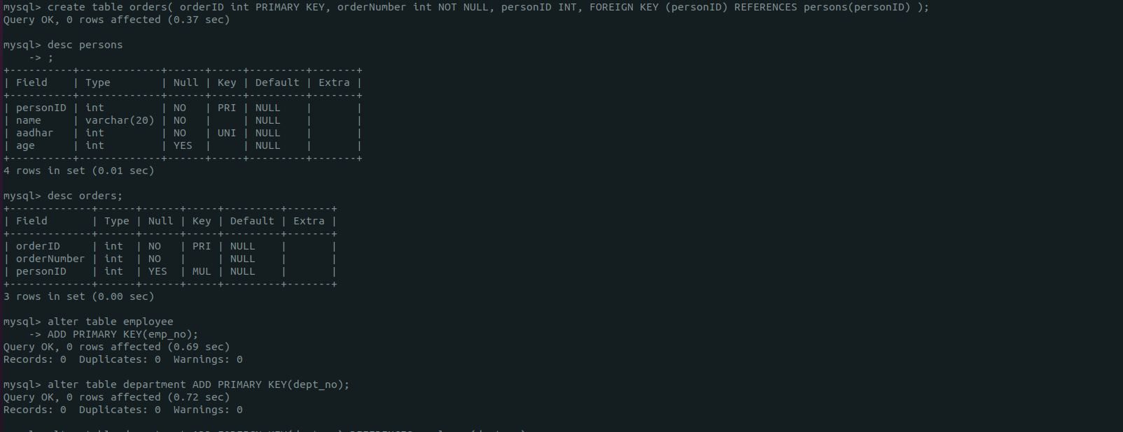

- Display the structure of Persons tables.
>> describe persons;

- Display the structure of Orders tables.
>> describe orders;

- Add emp_no as the primary key of the table Employee.
>> alter table employee add primary key(emp_no);

- Add dept_no as the primary key of the table Department.

>> alter table department add primary key(dept_no);

- Add dept_no in Employee table as the foreign key reference to the table Department with on delete cascade.

>> alter table employee add constraint fk foreign key(dept_no)rferences department(dept_no)on delete cascade;

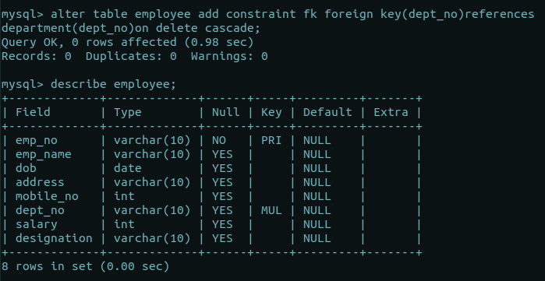
- Drop the primary key of the table Orders.

>> alter table orders drop primary key;

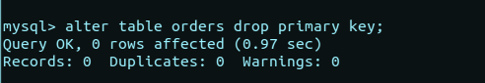
Experiment No: 3 Date : 20/02/2025
Familiarization of DML Commands

- Add at least 10 rows into the table Employee and Department.

>> insert into department values('D01','sales'),('D02','finance'),('D03','HR'),('D04','marketing'),('D05','security),
('D06','IT’),('D07','delivary'),('D08','export’),('D09','service'),('D10','purchase');

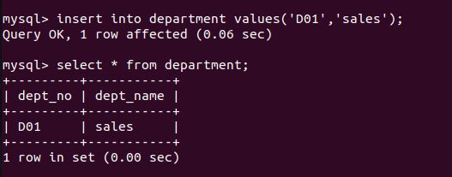

>> insert into employee values('emp1','john','1989- 14','london','8763926489','D01','4000','staff');

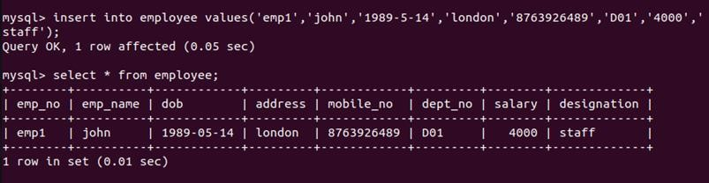

- Display all the records from the above tables.

>> select * from department;
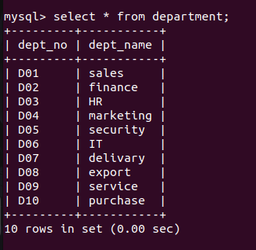

>> select * from employee;

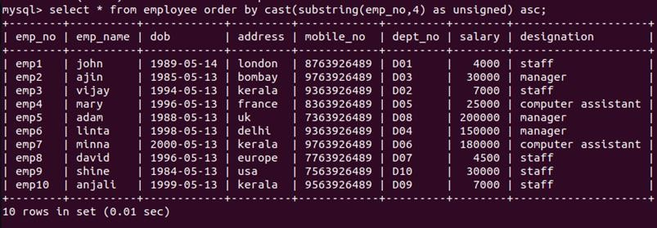

- Display the emp_no and name of employees from department no ‘D02’.
>> select emp_no,emp_name from employee where dept_no='D02';

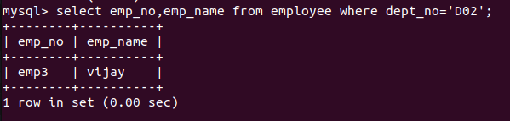
- Display emp_no, emp_name , designation, deptno and salary of employees in the descending order of salary.

>> select emp_no,emp_name,designation,dept_no,salary from employee order by salary desc;

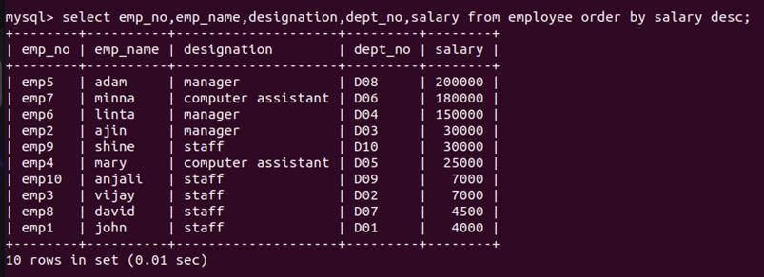

- Display the emp_no , name of employees whose salary is between 2000 and 5000
>> select emp_no,emp_name from employee where salary between 2000 and 5000;
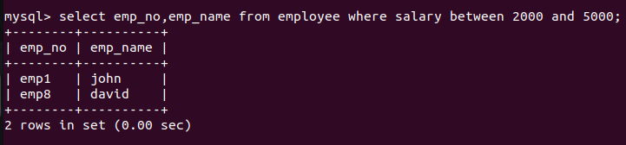

- Display the designations without duplicate values
>> select distinct designation from employee;

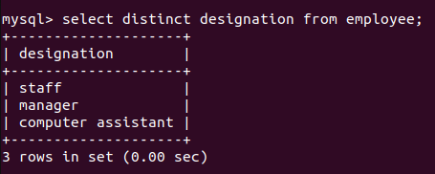
- Change the salary of employees to 45000 whose designation is 'Manager'
>> update employee set salary='45000' where designation='manager';
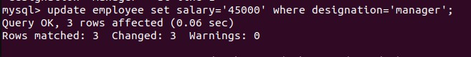

>> describe employee;
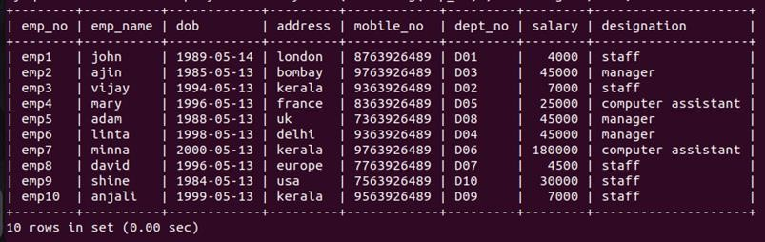

- Change the mobile number of employees named John

>> update employee set mobile_no='7834563489' where emp_name='john';

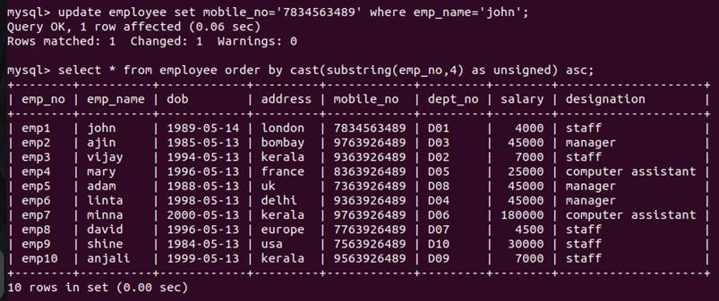
- Delete all employees whose salary is equal to Rs.7000

>> delete from employee where salary='7000';

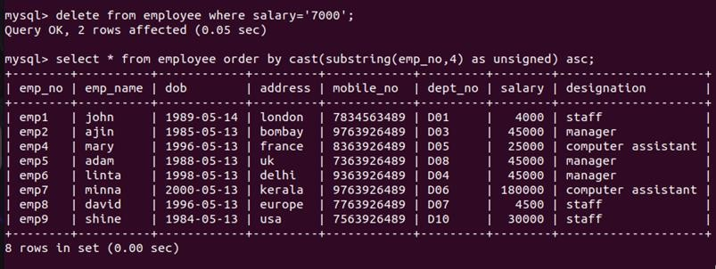

- Retrieve the name, mobile number of all employees whose name start with “A”.

>> select emp_name,mobile_no from employee where emp_name like'a%';
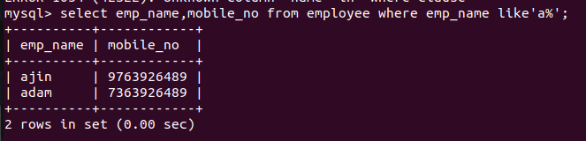

- Display the details of the employee whose name has at least three characters and salary greater than 20000.

>> select emp_name,mobile_no from employee where emp_name like'a%';
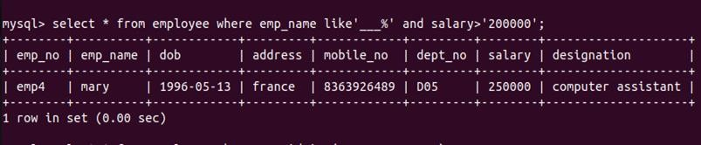
- Display the details of employees with empid ‘emp1’, ‘emp2’ and ‘emp6’.

>> select * from employee where emp_no in('emp1', 'emp2', 'emp6');
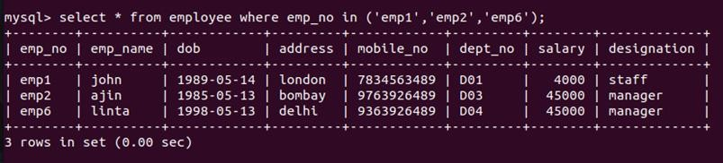

- Display employee name and employee id of those who have salary between 120000 and 300000.

>> select emp_name,emp_no from employee where salary between 120000 and 300000;
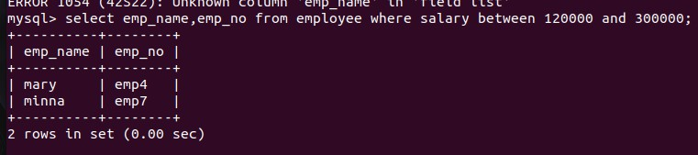

- Display the details of employees whose designation is ‘Manager’ or ‘Computer Assistant’.

>> select * from employee where designation in('manager', 'computer assistant');

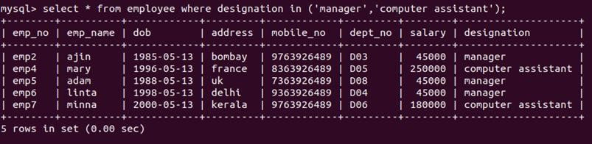
- Displays how many employees work for each department.

>> select dept_no,count(dept_no) from employee group by dept_no;

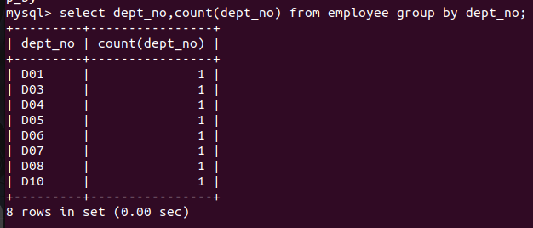

- Displays average salary of employees in each department.

>> select dept_no,avg(salary) from employee group by dept_no;
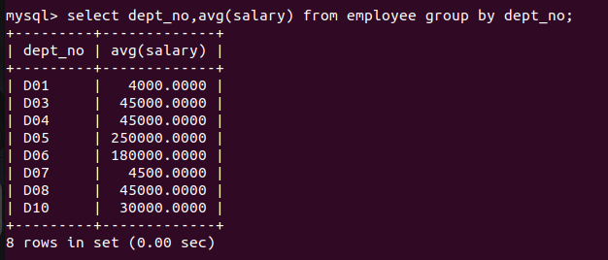

- Displays total salary of employees in each department.

>> select dept_no,sum(salary) from employee group by dept_no;
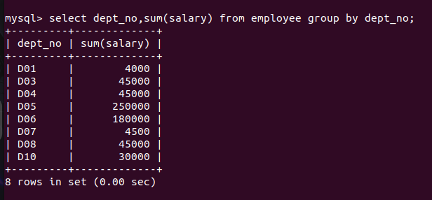

- Displays top and lower salary of employees in each department.

>> select dept_no,max(salary),min(salary) from employee group by dept_no;

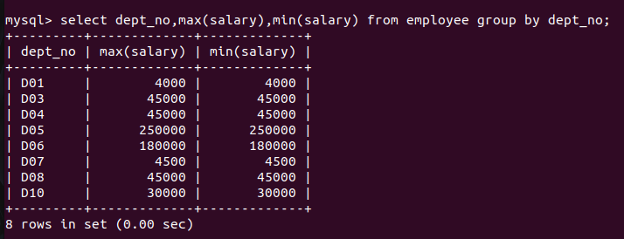

- Displays average salary of employees in all departments except department with department number ‘D05’.

>> select dept_no,avg(salary) from employee where dept_no!= 'D05' group by dept_no;
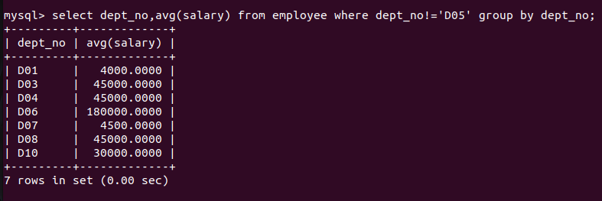

- Displays average salary of employees in all departments except department with department number ‘D01’ and average salary greater than 20000 in the ascending order of average salary.

>> select dept_no,avg(salary) from employee where dept_no!= 'D01' group by dept_no having avg(salary)> '20000' order by avg(salary) asc;

